**What is ServiceNow**

ServiceNow represents a cloud-based solution that fundamentally transforms organizational processes by automating and refining workflows across multiple divisions. It enables entities to enhance their IT services, human resources, governance, risk and compliance measures, financial operations, and asset management via a cohesive and accessible interface. Through the promotion of effortless integration with external systems and the provision of extensive solutions for incident, problem, and change management, ServiceNow assists enterprises in boosting productivity, lowering expenditures, and elevating service delivery. With its rich functionality and versatile nature, the system is a multi-dimensional tool that enables digital transformation and helps achieve operational excellence.

**Services of ServiceNow**

ServiceNow provides an extensive array of services that aim to improve and optimize business processes across many areas. The following gives an in-depth look at each service:

1. The IT Service Management (ITSM

Incident Management: Rapidly reinstates standard service operations to mitigate business effects. Automated workflows alongside AI-informed insights facilitate the efficient identification and resolution of incidents.

Problem management: Focuses on the diagnosis of the root cause of incidents to prevent their recurrence. It provides trend analysis service to manage problem well before the occurrence of an incident.

Change Management: Ensures that changes to IT services are planned and executed in a controlled manner with minimal disruption. It includes risk assessment and approval workflows for managing and tracking changes effectively.

2. HR Service Delivery

Employee Onboarding: Makes the onboarding process more efficient through automation of different tasks and provides one centralized place for new employees to access necessary resources and information.

Case Management: Supports the enhancement of human resources through efficient tracking and managing of issues and employee requests. With predefined flows, consistent and personalized service delivery is offered.

Employee Life Cycle Events: Provides a range of human resources events from promotions, transfers to offboarding, ensuring a smooth transition and consistency within organizational policies.

3. Governance, Risk, and Compliance

Policy and Compliance Management enables the automation of policy creation, dissemination, and monitoring to ensure organizations adhere to regulatory requirements.

Risk management involves the identification, assessment, and mitigation of risks through a centralized platform. It unifies risk data throughout an organization, providing full insight into risk exposure.

Audit Management: The module facilitates audit processes in the easiest way by automating audit planning, execution, and reporting. Audits will be comprehensive, timely, and in compliance with standards.

4. Financial Operations Management

Financial Planning and Analysis: Provides aggregated financial information to deliver current insight and analytical assessments that help with accurate forecasting and making strategic decisions.

Expense Management: Automates business expense tracking, approval, and reimbursement to make sure everything is within policy and eliminate processing time.

Billing and Invoicing: Automated invoicing and tracking of payments expedite the process while ensuring its accuracy.

5. Integration Hub

Seamless Connectivity: Facilitates the integration of diverse enterprise systems and external applications, thereby promoting efficient data interchange and the automation of processes.

Custom Integrations: Provides resources for creating custom integrations that are tailored to specific organizational needs and thus maintain integrated functionality across all systems.

Pre-built Connectors: Offers a large set of pre-built connectors for popular applications, which reduces integration time and effort with different systems.

6. Asset Management

IT Asset Lifecycle Management: It tracks the life of IT assets right from procurement to retirement. It helps with the optimization of asset usage and reduction in the cost of asset management.

Software Asset Management: Ensures software licensing agreements compliance and optimizes software usage inside the organization, therefore minimizing the risk of audit penalties.

Hardware Asset Management encompasses the processes of acquiring, deploying, maintaining, and disposing of hardware assets, thereby guaranteeing precise tracking and the effective utilization of resources.

7. Business Management

Project Portfolio Management (PPM): Provides a centralized platform for managing and prioritizing projects, resources, and budgets. It aligns projects with business objectives to maximize value.

Resource Management: Amplifies the way resources are allocated and utilized across projects and operations to ensure that the right resources are available in a timely manner.

Strategic planning enables long-term decision-making and planning through insights and data analyses that advise strategic initiatives and investment choices.

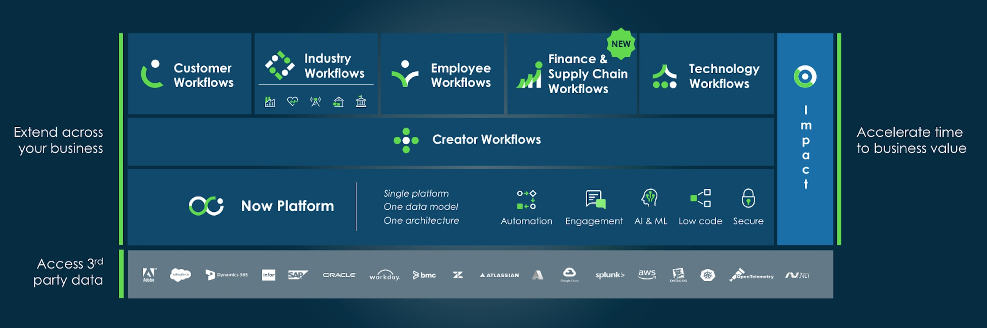

**How to get free SNOW instances**

Getting a free ServiceNow instance, popularly known as a "personal developer instance," is a very useful asset to have for learning, developing, and testing the various aspects of the platform.

Detailed Steps to Get a Free Instance of ServiceNow

Step 1: Sign up for ServiceNow Developer program.

Open the ServiceNow Developer Site by accessing developer.servicenow.com.

Create an account: If you don't have an account yet, click on "Register" and complete the fields in order to create your account. If you do have an account, log in.

Step 2: Provision a Personal Developer Instance

Developer Dashboard Following is the developer dashboard that you will be redirected to once you log in. You can find resources, such as requesting a personal instance.

Request an Instance: Click on the “Request Instance” button. You’ll be prompted to select the version of the ServiceNow platform you’d like to use. It’s generally recommended to select the latest version to access the newest features and improvements.

Step 3: Launch Your Instance

Instance Details: After requesting, you’ll receive your instance details, including the URL, admin username, and password. These details will also be sent to your registered email address.

Access Your Instance: Open a web browser and navigate to the provided URL. Log in using your administrator credentials. You will have full administrator access to the instance, where you can learn, build, and evaluate a host of functionality on ServiceNow.

Step 4: Employ Your Instance

Learning and Development: Apply this example to learn application development, workflow configuration, and how to achieve the platform's capabilities. For detailed information, refer to the extensive documentation and learning modules available in ServiceNow.

Community and Support: Engage with the ServiceNow Developer Community to collaborate with other developers, request assistance, and share expertise. Also, leverage forums, blogs, and webinars as additional learning tools.

Step 5: Maintenance and Renewal

Instance Activity: The ongoing availability of your personal developer instance relies on its use from time to time. You have to log in and do something periodically to keep it alive.

Renewal: Should your instance become dormant, then ServiceNow reserves the right to reclaim your instance. Of course, you can always request a new instance by repeating these same steps.

How to Maximize Your Free ServiceNow Instance

Stay tuned: regularly go through the platform update and new features to keep your skills updated.

Use Cases: Follow different use cases and scenarios to extend your understanding of what ServiceNow can offer. Engage in Community: Engage in discussions and webinars, including using knowledge shared by other developers in the community.

**How to become a SNOW developer**

To become a ServiceNow developer, one needs to gain both technical skills and certification, besides working experience. Here is a quick guide on how to make it happen:

1. Understanding ServiceNow

Platform Overview: Acquaint yourself with the ServiceNow platform, including its various modules and functionalities.

Key Concepts: Learn the fundamental concepts of workflows, tables, forms, and business rules.

2. Education and Learning

Official Training: ServiceNow Officially Provided Training can be found on the ServiceNow Developers portal.

Online Resources: Leverage free online resources, tutorials, and documentation provided by ServiceNow and educational platforms like Coursera and Udemy.

3. Establishing an Individual Developer Instance

Example Request: Request a free personal developer instance through the ServiceNow Developer Site.

Hands-On Practice: Using this example, practice and try out application development and workflow configuration.

4. Core Competencies Development

Scripting: Learn JavaScript, used for advanced development in ServiceNow.

ServiceNow Scripting: Learn about GlideRecord, GlideSystem, and other ServiceNow-specific APIs.

UI Design: Learning HTML, CSS, and AngularJS to be able to develop custom interfaces.

5. Certifications

CSA - Certified System Administrator: Obtain this associated certification to confirm your knowledge in the core ServiceNow platform.

Certified Application Developer-CAD: Obtain this CAD certification to confirm your application development skills on the ServiceNow platform.

Other advanced certifications include Certified Implementation Specialist, CIS, at different modules including ITSM, HR.

6. Professional Experience

Projects: Practice with real or mock projects in the working of your skill.

Internships/Jobs: Look for internships or jobs that would provide valuable hands-on experience.

Community Contribution: Contribute to the ServiceNow developer community through forums, solution sharing, and contributing to open-source projects.

7. Networking and Community Building

Developer Forums: Avail yourself of forums and discussion groups, such as the ServiceNow Community and Stack Overflow.

User Groups: Engage in the local user groups of ServiceNow and events.

Webinars and Conferences: Attend webinars and events like Knowledge Conference related to ServiceNow to stay updated on the latest trends and network with other professionals.

8. Lifelong Learning

Stay Current: Update your knowledge to cover the most recent ServiceNow releases and new features. Advanced Modules: Learn and master modules such as ITOM, ITBM, and SecOps with advancement.

**ServiceNow certification training**

ServiceNow certification training enables participants to understand a platform that is leading an IT service management revolution. Apart from enriching your resume with a credential, it empowers you with the ability to streamline processes, boost efficiency, and drive innovation within organizations. This is not just tool training; it's learning a framework that helps you resolve day-to-day challenges, optimize workflows, and enable strategic goals. The practical experience gained during this training can significantly enhance your ability to apply effective solutions and adapt to dynamic technological environments.

**ServiceNow components**

ServiceNow is an integrated ITSM platform that contains various components, which make IT operations more effective and automated. Let's have a closer look at its key components:

Incident Management:

* Objective: Manages and resolves IT incidents to restore normal service operation as quickly as possible.
* Features: Automate workflows for ticketing, prioritization, tracking of incidents, and resolution.

Issue Management:

* Purpose: Identifies and manages the root causes of incidents to prevent future occurrences.
* Features: included are problem identification, root cause analysis, workarounds, and resolution documentation.

Change Management:

* Purpose: To ensure the lifecycle of changes to IT systems are controlled, minimizing risk and impact.
* Features: Change requests, impact analysis, approval workflows, and change implementation tracking.

Configuration Management Database (CMDB):

* Objective: Preserves a unified repository of information technology assets along with their interconnections.
* Features and functionalities include asset tracking, configuration item relationships, and impact analysis.

Knowledge Management:

* Knowledge: Capture and sharing for better decision making and efficiency.
* Features Knowledge articles, categorization, search, and article lifecycle management.

Service Catalog:

* Objective: Provides an easily accessible platform for seeking IT services and products.
* The key features include service offerings, request forms, fulfilment workflows, and user self-service.

Request Management:

* Purpose: Manages and tracks requests for service from initiation to fulfilment.
* Features: Tracking of requests, approval workflow, and automation of fulfilment processes.

Asset Management:

* Purpose: Manages the lifecycle of IT assets from procurement to disposal.
* Features: Asset tracking, lifecycle management, and reporting.

Service Level Management:

* Purpose: To ensure that the IT services meet agreed levels.
* Features: SLA definition, monitoring, and reporting.

Orchestration:

* Purpose: Automates IT processes and workflows across systems.
* Features: Event-driven workflow automation, integration of third-party systems, and task execution.

Virtual Agent:

* Objective: Provides automated support through chatbots and virtual assistants.
* Features: AI-powered communication, natural language processing, and response automation.

Performance Analytics:

* Purpose: Measures and analyses performance metrics to drive improvements.
* Features: Dashboards, reports, and KPIs (Key Performance Indicators).

Security Incident Response:

Goal: Oversees and addresses security incidents to protect information technology resources.

* Features: Incident tracking, investigation workflows, and remediation. Governance, Risk Management, and Compliance: Purpose: Manages compliance with regulations and assesses risk.
* Features: Policy management, risk assessment, and audit tracking.

Project Portfolio Management (PPM).

* Objective: Oversees and monitors information technology projects and portfolios.
* Features Project planning, resource allocation, and project tracking.

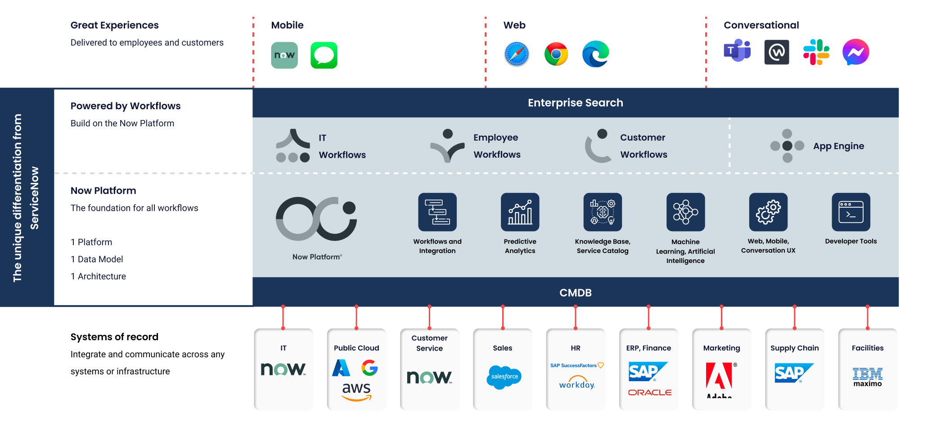

**Workflow and Process Automation based on ITIL Principles**

ITIL Principles: ServiceNow uses ITIL for the automation of IT service management workflows. This ensures standardization, efficiency, and best-practice compliance. Automation would include incident, change, and problem management to enhance the services provided and reduce the manual effort required.

**IT, Security, HR Service Delivery**

IT Service Delivery: Automates everything, from incident resolution and the implementation of changes to service requests, that is involved with IT operations.

Security: Automates security incident response and compliance management, respectively, to safeguard IT assets and data.

HR Service Delivery: Oversees human resource procedures including employee onboarding, case management, and service requests, thereby improving both the employee experience and operational effectiveness.

**Customer service and commercial usages**

Automate and optimize the customer service functions, including case management and service request management, to further develop customer satisfaction.

Business Applications: Adapts and automates the workflow of business applications, including project management and financial management, to suit organizational needs.

**Admin and Developer Roles**

Admin: Manages system configurations, user permissions, and overall platform maintenance to ensure operational stability.

Developer: Creates custom applications, scripts, and workflow designs to extend and tailor ServiceNow functionality for specific business needs.

**Important Customers**

Primary Customers-ServiceNow's services include industries and domains such as IT, human resources, customer service, and business operations that cater to Fortune 500 companies, government agencies, healthcare organizations, and many more.

**ServiceNow Growth**

Growth: As ServiceNow is fully integrated with ITSM capabilities, it continues to grow into areas such as human resources, security, and business management, fueled by a growing demand for integrated digital workflows.



**ServiceNow Architecture**

Architecture: ServiceNow is designed on the cloud, adopting a multi-instance model-one instance for each customer-where each one maintains an environment in isolation. It has a core platform of application services that are integrative, powered by infrastructure that is robust yet scalable.

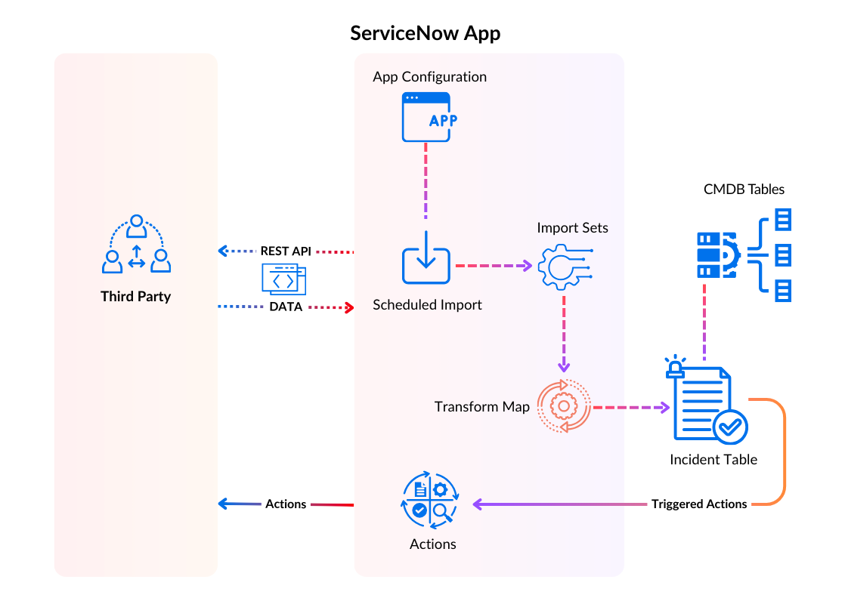

**Who Uses ServiceNow**

IT departments, HR teams, customer service units, and business process managers are examples of consumers using ServiceNow to manage and automate their own work and services.

**Definition of a Catalog**

It also allows users to request multiple IT services, products, and business services through an easily accessible interface-the Service Catalog. It provides users with a single-point interface for raising service requests, making it easy for users to access and place orders for the resources they need.

**Dashboard Development**

Dashboard: Dashboards, within the ServiceNow suite, provide a graphical representation of the most important Key Performance Indicators (KPIs), metrics, and information relevant to IT operations, projects, and business processes. This dashboard can be customized to show relevant information and insights for the purpose of decision-making and performance monitoring.

